The problems I still see with this solution of common deliverables if duplicity, making the gate genuinely large. 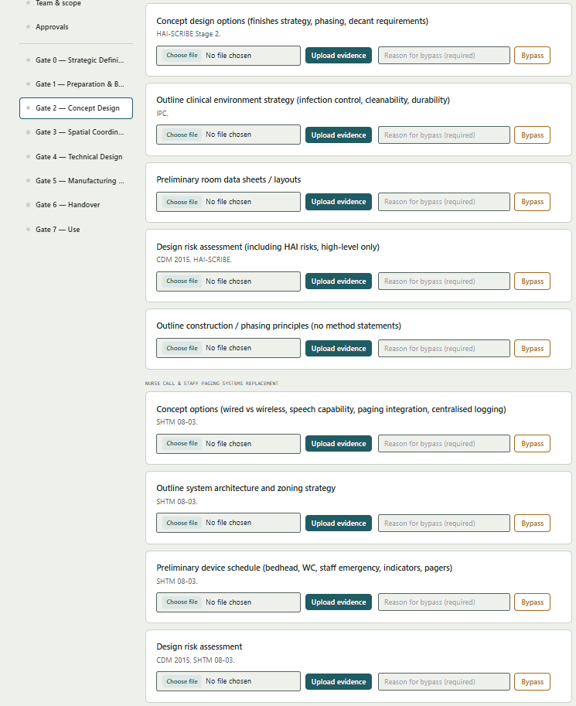

Solution

What if we actuall had common delierables i.e. Conception Options as the header, but listed out each deliverable underneath within the box, with its own “choose file, upload evidence , “reaosn for bypas”
Concept options
1. finishes strategy, phasing, decant requirements - HAI-SCRIBE Stage 2.
2. wired vs wireless, speech capability, paging integration, centralised logging -SHTM 08-03.




